SWE

Assignment-3

Group Members

|  |  |
| --- | --- |
| Roll Number | Name |
| Bsef20a026 | Neha |
| Bsef20a036 | Aiza |

12/13/2023

**Assignment -3**

**Tasks**

Download the ARGOUML Source Code in 3 different Programming Languages

<https://github.com/argouml-tigris-org>  
Provide the Code Quality Results from using three different tools of ARGOUML  
Provide Feature Information Reported   
Provide Bugs issues  
Provide Project Release Report  
Provide common Pattern available in All Releases

**Table Of Content**

|  |  |  |
| --- | --- | --- |
| No# | Task | Page# |
| 1 | Download the ARGOUML Source Code in 3 different Programming Languages | 2 |
| 2 | Provide the Code Quality Results from using three different tools of ARGOUML | 2 |
| 3 | Provide Feature Information Reported |  |
| 4 | Provide Bugs issues |  |
| 5 | Provide Project Release Report |  |
| 6 | Provide common Pattern available in All Releases |  |

Task: 1

Download the ARGOUML Source Code in 3 different Programming Languages

[Argouml-Java](https://github.com/NEHANOVEED123/Argouml-SWE-Assignment3-Java)

[Argouml-Cpp](https://github.com/NEHANOVEED123/Argouml-SWE-Assignment3-Cpp)

[Argouml-Csharp](https://github.com/NEHANOVEED123/Argouml-SWE-Assignment3-Csharp)

Task: 2

Provide the Code Quality Results from using three different tools of ARGOUML

|  |  |  |
| --- | --- | --- |
| No# | Tools | Description |
| 1 | Code scene | 1. Code health-Prioritize technical debt 2. Red code, Yellow code, Green Code 3. Hotspot code health, Average code health 4. Worst performer |
| 2 | Codacy | 1. Code pattern 2. Issues of each files 3. Issue, cyclomatic complexity, Duplication 4. Coverage |
| 3 | Code Factor | 1. Gave actionable refactoring tip 2. Issue of each files 3. Complexity, code style, maintainability |
| 4 | Codeac | 1. Technical Debt 2. Code errors, code warning, issues 3. Feedback 4. Code duplication between files |
| 5 | DeepSource | 1. Bug risk, coverage, security, code style, performance 2. Anti-pattern 3. Auto fix 4. Code health |

**Repository 1:** [**Argouml-SWE-Assignment3-Cpp**](https://github.com/NEHANOVEED123/Argouml-SWE-Assignment3-Cpp)

[Argouml-Cpp](https://github.com/NEHANOVEED123/Argouml-SWE-Assignment3-Cpp)

Tools:

1. deep source: [deepsource report](https://app.deepsource.com/report/515e4705-187b-4609-b6be-2e3ffdfffd0c)
2. codescene : [code-health-report](https://drive.google.com/file/d/1spRAdxAIdC1WEoHTKNPuU9Ziiv1fZtrj/view?usp=sharing) (drive link)
3. codacy : [codacy badger](https://app.codacy.com/gh/NEHANOVEED123/Argouml-SWE-Assignment3-Cpp/dashboard?utm_source=gh&utm_medium=referral&utm_content=&utm_campaign=Badge_grade) (save in read me)
4. codeac : [codeac Badger](https://app.codeac.io/github/NEHANOVEED123/Argouml-SWE-Assignment3-Cpp) (save in read me)
5. codefactor

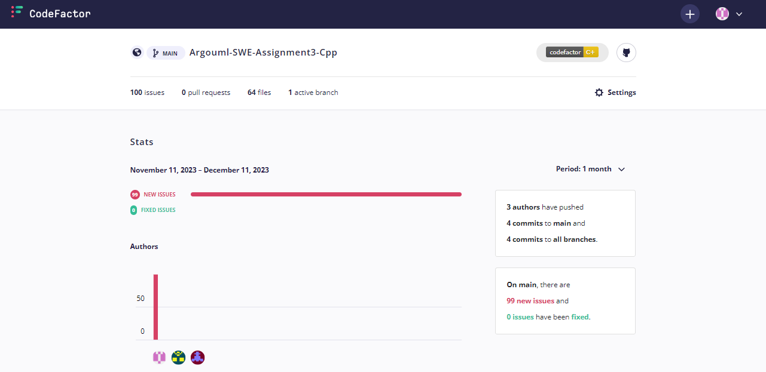

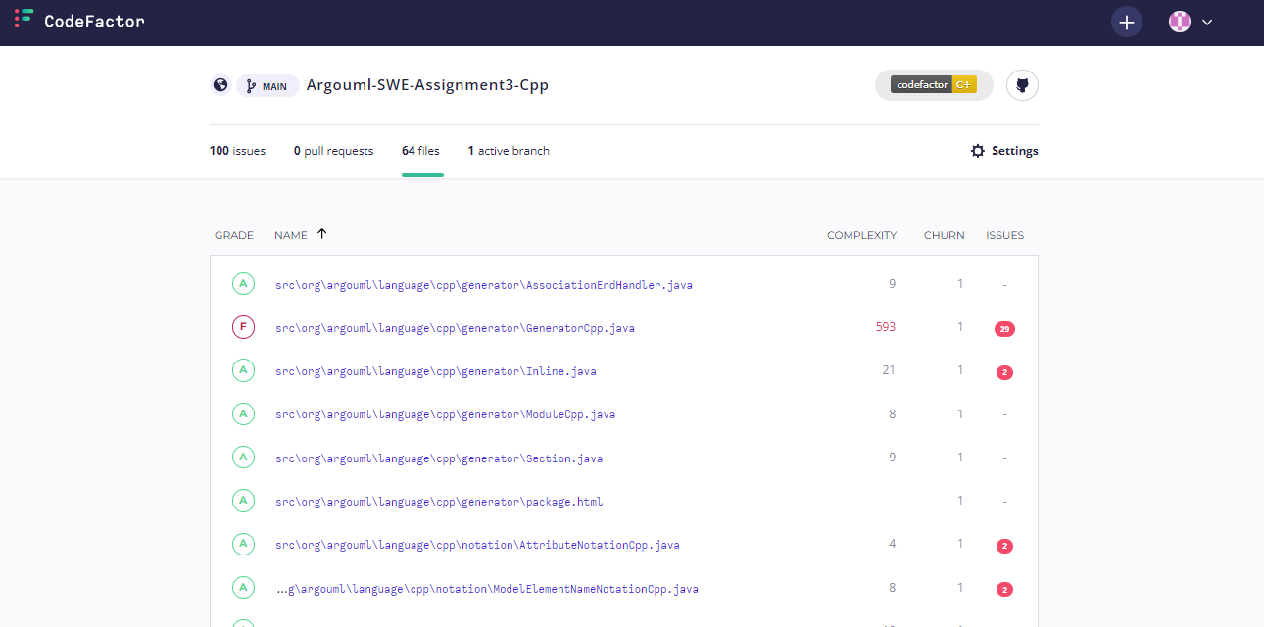

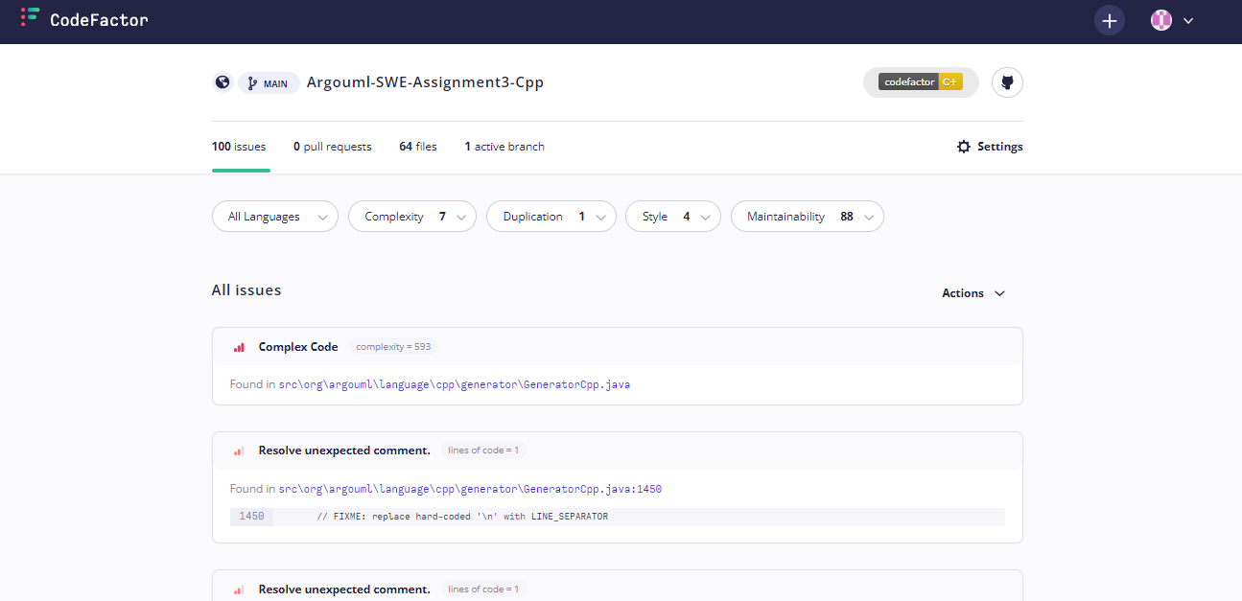

**Repository 2:** [**Argouml-SWE-Assignment3-Java**](https://github.com/NEHANOVEED123/Argouml-SWE-Assignment3-Java)

[Argouml-Java](https://github.com/NEHANOVEED123/Argouml-SWE-Assignment3-Java)

Tools:

1. deep source: [deepsource report](https://app.deepsource.com/report/e89fe691-b496-4ffe-b740-679b3a269c31) ([issue](https://app.deepsource.com/gh/NEHANOVEED123/Argouml-SWE-Assignment3-Java/issues/?category=all&page=1))
2. codescene : [code-health-report java](https://drive.google.com/file/d/1YDlI7Vlil3JE8MGOq9UC0KdiwT8uzi4T/view)(drive link)
3. codacy :[codacy badge](https://app.codacy.com/gh/NEHANOVEED123/Argouml-SWE-Assignment3-Java/dashboard?utm_source=gh&utm_medium=referral&utm_content=&utm_campaign=Badge_grade) (save in read me)
4. codeac :[codeac badge](https://app.codeac.io/github/NEHANOVEED123/Argouml-SWE-Assignment3-Java) (save in read me)

**Repository 3:** [**Argouml-SWE-Assignment3-Csharp**](https://github.com/NEHANOVEED123/Argouml-SWE-Assignment3-Csharp)

[Argouml-Csharp](https://github.com/NEHANOVEED123/Argouml-SWE-Assignment3-Csharp)

Tools:

1. codescene : [code-health-report csharp](https://drive.google.com/file/d/1YDlI7Vlil3JE8MGOq9UC0KdiwT8uzi4T/view)(drive link)
2. codacy : [codacy badge](https://app.codacy.com/gh/NEHANOVEED123/Argouml-SWE-Assignment3-Csharp/dashboard?utm_source=gh&utm_medium=referral&utm_content=&utm_campaign=Badge_grade)(save in read me)
3. codeac :[codeac badge](https://app.codeac.io/github/NEHANOVEED123/Argouml-SWE-Assignment3-Csharp) (save in read me)

Task: 3

Provide Feature Information Reported

## ArgoUML Features : <https://argouml-tigris-org.github.io/tigris/argouml/features.html>

ArgoUML provides the following features.

1. Support for all 9 UML 1.4 Diagrams
2. Platform-independent, compatible with Java 5+
3. Easy installation via Java Web Start
4. Standard UML 1.4 Metamodel compliance
5. UML Profile support with provided profiles for Java, C++, and UML 1.4
6. XMI Support for easy interchange with other tools
7. Export diagrams in various formats, including GIF, PNG, PS, EPS, PGML, and SVG
8. Internationalization in ten languages
9. Advanced diagram editing and zoom features
10. OCL (Object Constraint Language) support for constraint modeling
11. Forward and reverse engineering capabilities
12. Cognitive support, design critics, and corrective automations
13. "To Do" list for organizing and managing tasks
14. User model for tailoring suggestions based on the designer's context
15. Checklists for design reviews
16. Explorer perspectives with customizable rules
17. Multiple, overlapping views for a comprehensive understanding of complex designs

Task: 4

Provide Bugs issues

Issues before making clone <https://github.com/argouml-tigris-org/argouml/issues>

**Repository 1:** [**Argouml-SWE-Assignment3-Cpp**](https://github.com/NEHANOVEED123/Argouml-SWE-Assignment3-Cpp)

deep source:

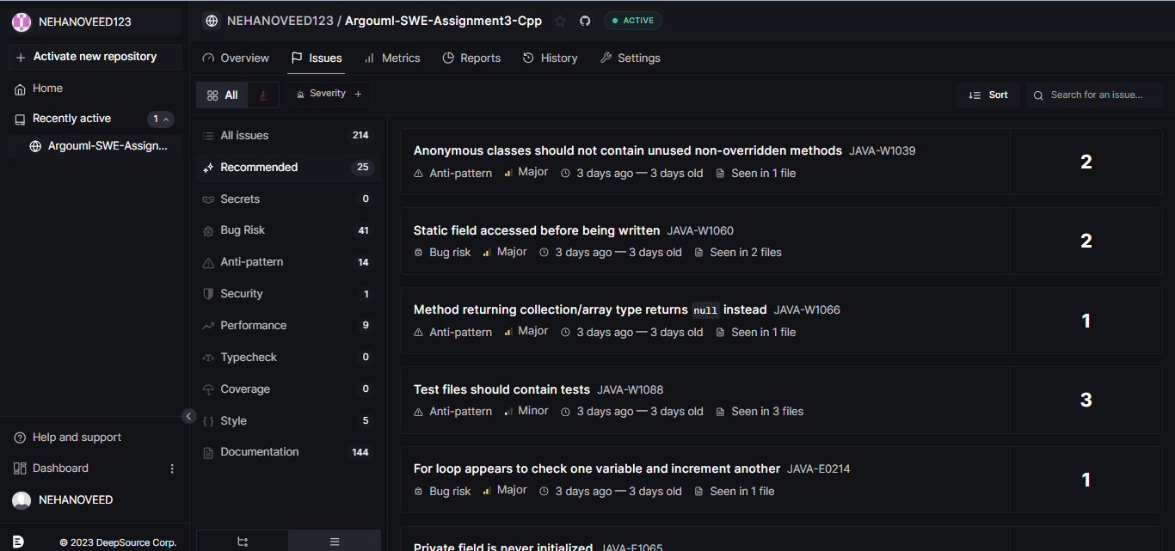

Code factor:

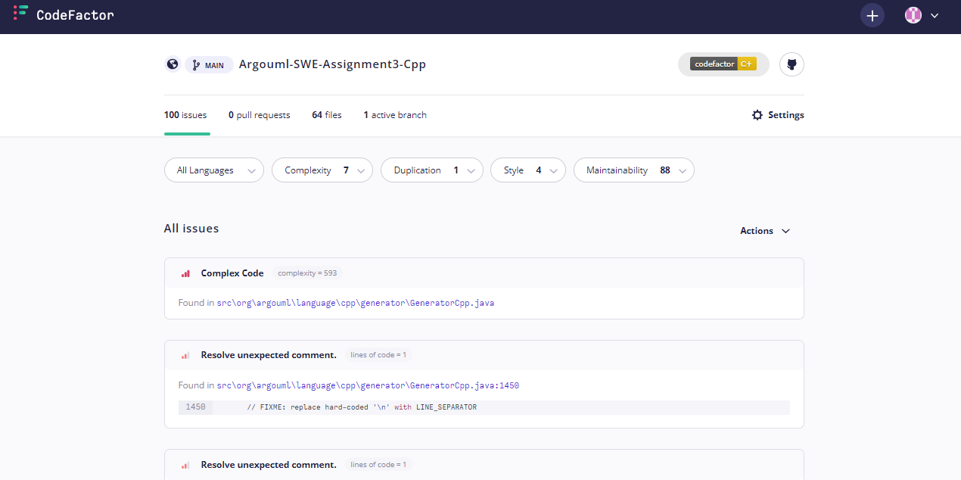

Codeac:

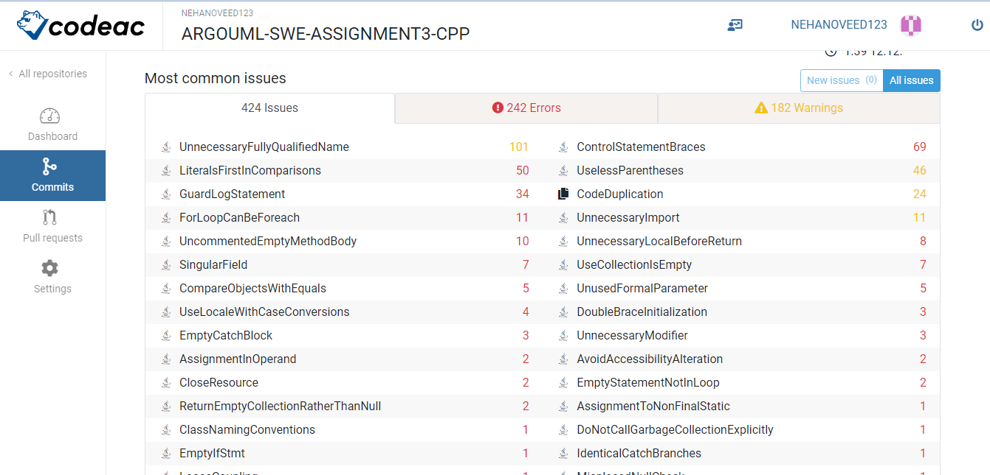

Codacy:

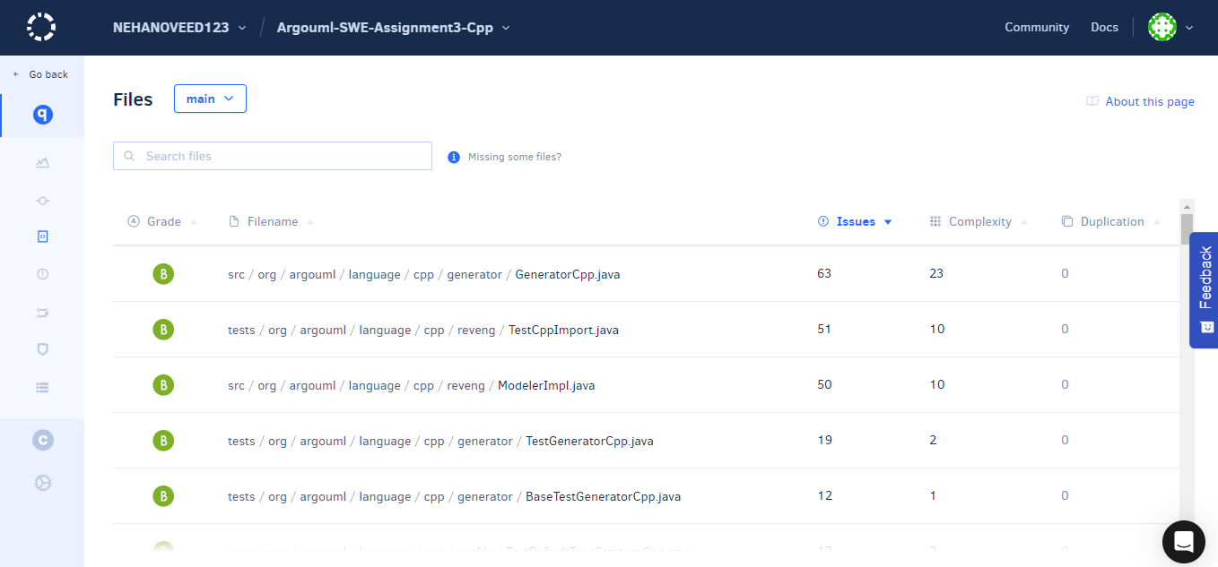

Code scene: 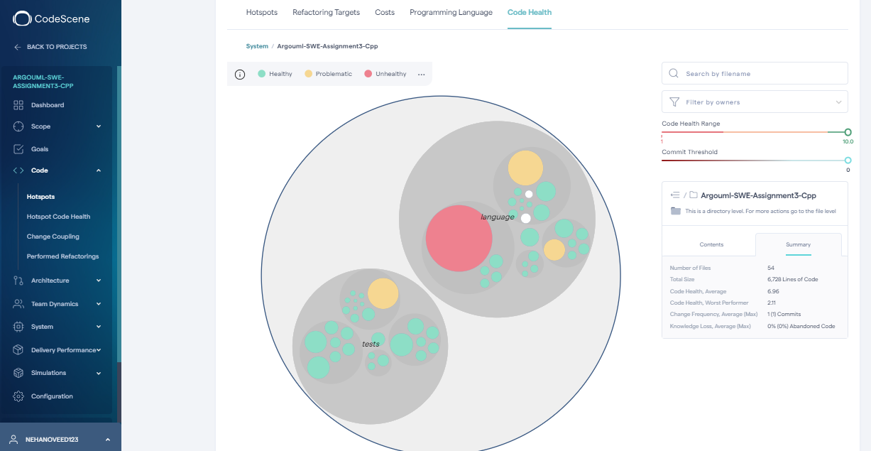

**Repository 2:** [**Argouml-SWE-Assignment3-Java**](https://github.com/NEHANOVEED123/Argouml-SWE-Assignment3-Java)

Codacy:

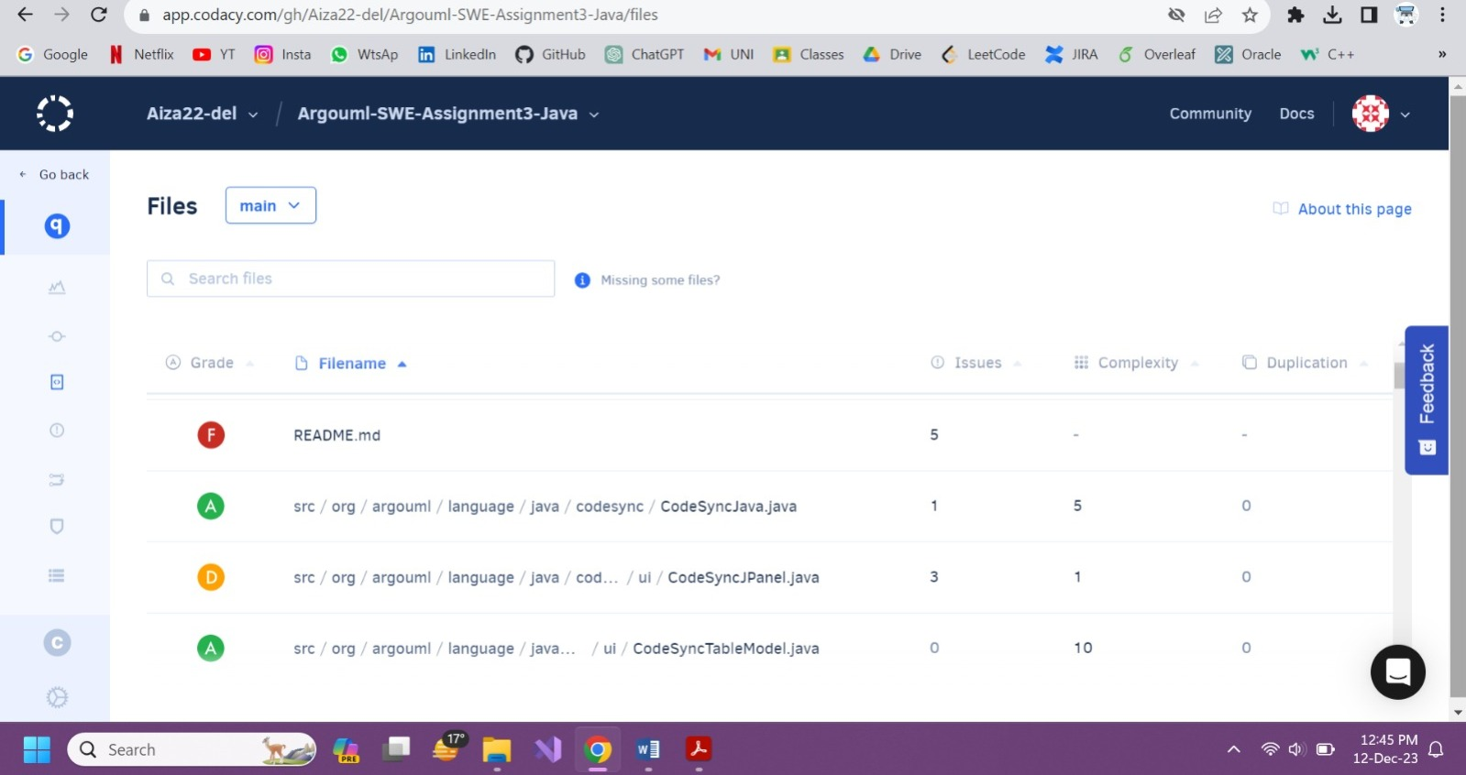

CodeScene:

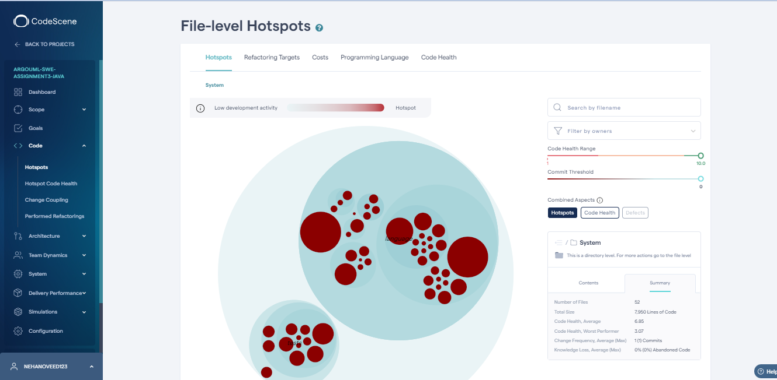

**Repository 3:** [**Argouml-SWE-Assignment3-Csharp**](https://github.com/NEHANOVEED123/Argouml-SWE-Assignment3-Csharp)

Codacy:

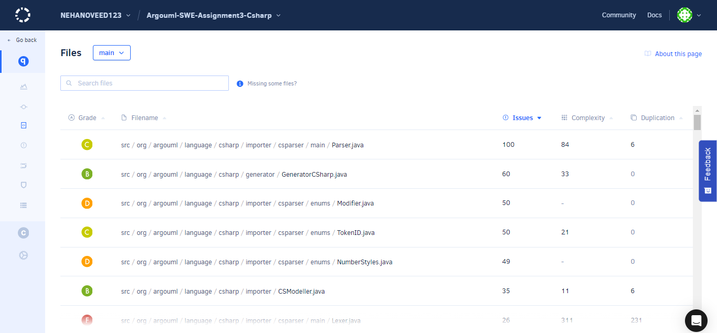

Code scene:

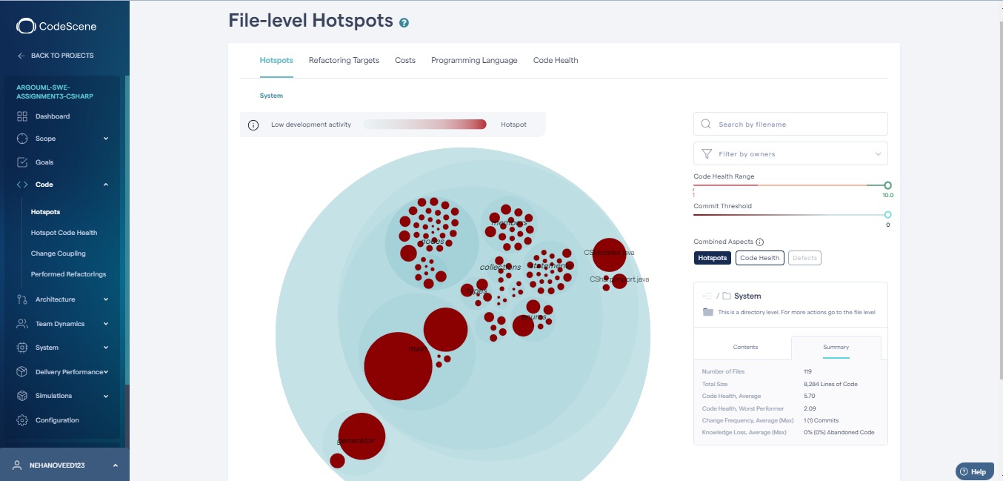

Task: 5

Provide Project Release Report

Using wiki page of Argouml <https://github.com/argouml-tigris-org/argouml/wiki>

<https://github.com/argouml-tigris-org/argouml/releases>

* Releases: <https://github.com/argouml-tigris-org/argouml/releases> (old from the work done at tigris). The [GITHUB_IMPORT release](https://github.com/argouml-tigris-org/argouml/releases/tag/GITHUB_IMPORT) contains a dump of all old issues.

Release tags of each repository before clone

[argouml-cpp/tags](https://github.com/argouml-tigris-org/argouml-cpp/tags)

[argouml-java/tag](https://github.com/argouml-tigris-org/argouml-java/tag)

[argouml-csharp/tags](https://github.com/argouml-tigris-org/argouml-csharp/tags)

Task: 6

Provide common Pattern available in All Releases

Cpp [pattern - codacy tools](https://app.codacy.com/gh/NEHANOVEED123/Argouml-SWE-Assignment3-Cpp/issues/current?patternIds=PMD_category_java_codestyle_UnnecessaryFullyQualifiedName%2CCheckstyle_EmptyLineSeparator%2CCheckstyle_FileTabCharacter%2CCheckstyle_LineLength%2CPMD_category_java_codestyle_FieldDeclarationsShouldBeAtStartOfClass%2CCheckstyle_AvoidStarImport%2CPMD_category_java_performance_StringInstantiation%2CPMD_category_java_design_NPathComplexity%2CPMD_category_java_bestpractices_JUnitTestsShouldIncludeAssert%2CPMD_category_java_documentation_UncommentedEmptyMethodBody%2CPMD_category_java_design_AvoidThrowingRawExceptionTypes%2CPMD_category_java_errorprone_CompareObjectsWithEquals%2CPMD_category_java_bestpractices_UnusedFormalParameter%2CPMD_category_java_design_SingularField%2CPMD_category_java_bestpractices_AvoidReassigningParameters%2CCheckstyle_CommentsIndentation%2CPMD_category_java_design_CollapsibleIfStatements%2CPMD_category_java_errorprone_MisplacedNullCheck%2Ccppcheck_unreadVariable%2CPMD_category_java_codestyle_UnnecessaryCon)

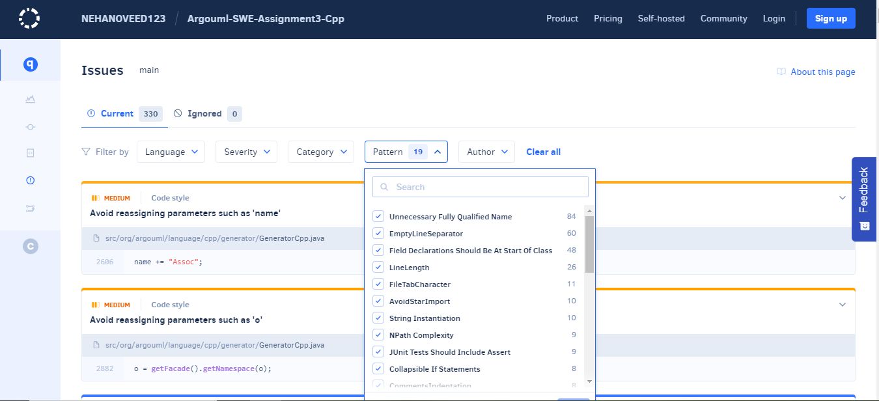

**Repository 2:** [**Argouml-SWE-Assignment3-Java**](https://github.com/NEHANOVEED123/Argouml-SWE-Assignment3-Java)

[codacy java patterns](https://app.codacy.com/gh/Aiza22-del/Argouml-SWE-Assignment3-Java/issues/current?patternIds=Checkstyle_EmptyLineSeparator%2CCheckstyle_LineLength%2CPMD_category_java_codestyle_FieldDeclarationsShouldBeAtStartOfClass%2CCheckstyle_FileTabCharacter%2CPMD_category_java_design_NPathComplexity%2CPMD_category_java_bestpractices_AvoidReassigningParameters%2CCheckstyle_CommentsIndentation%2CPMD_category_java_design_SingularField%2CCheckstyle_OneTopLevelClass%2CPMD_category_java_bestpractices_UnusedPrivateField%2CPMD_category_java_errorprone_CompareObjectsWithEquals%2Cremark-lint-list-item-indent%2CPMD_category_java_bestpractices_UnusedFormalParameter%2CCheckstyle_EmptyBlock%2CPMD_category_java_bestpractices_UnusedLocalVariable%2CPMD_category_java_bestpractices_UnusedPrivateMethod%2CPMD_category_java_errorprone_UnnecessaryCaseChange%2CPMD_category_java_codestyle_MethodNamingConventions)

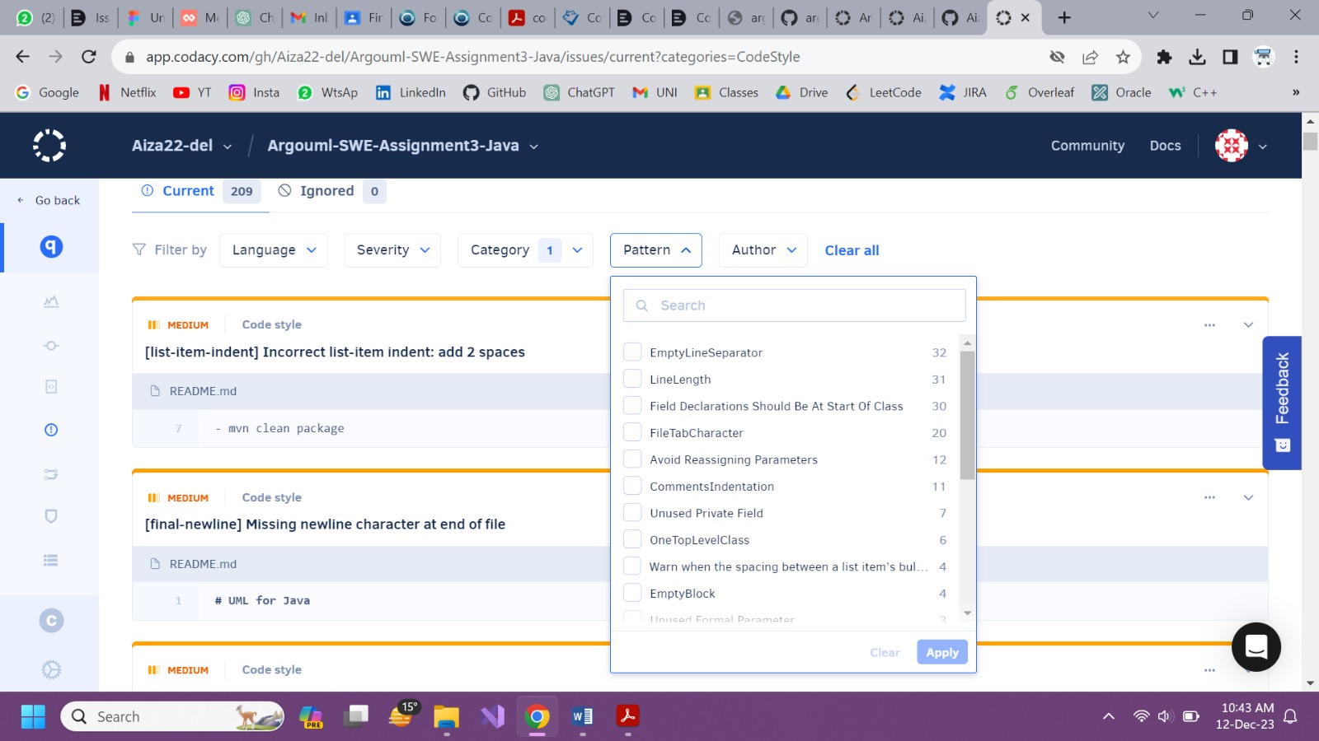

**Repository 3:** [**Argouml-SWE-Assignment3-Csharp**](https://github.com/NEHANOVEED123/Argouml-SWE-Assignment3-Csharp)

[Codacy Pattern csharp](https://app.codacy.com/gh/NEHANOVEED123/Argouml-SWE-Assignment3-Csharp/issues/current?patternIds=Checkstyle_EmptyLineSeparator%2CCheckstyle_LineLength%2CPMD_category_java_codestyle_MethodNamingConventions%2CCheckstyle_FileTabCharacter%2CPMD_category_java_codestyle_FieldDeclarationsShouldBeAtStartOfClass%2CCheckstyle_CommentsIndentation%2CPMD_category_java_errorprone_AssignmentToNonFinalStatic%2CPMD_category_java_design_NPathComplexity%2CCheckstyle_AvoidStarImport%2CPMD_category_java_bestpractices_UnusedPrivateField%2CPMD_category_java_bestpractices_UnusedPrivateMethod%2CPMD_category_java_documentation_UncommentedEmptyMethodBody%2CPMD_category_java_bestpractices_AvoidReassigningParameters%2CPMD_category_java_bestpractices_UnusedLocalVariable%2CPMD_category_java_codestyle_UnnecessaryConstructor%2CPMD_category_java_design_SimplifyBooleanExpressions%2CPMD_category_java_design_SingularField%2CCheckstyle_UnusedImports%2CPMD_category_java_design_CollapsibleIfStatements%2CPMD_category_java_bestpractices_UnusedFormalParameter%2CPMD_category_java_errorprone_CompareObjectsWithEquals%2CCheckstyle_EmptyBlock%2CPMD_category_java_codestyle_UnnecessaryFullyQualifiedName%2CPMD_category_java_bestpractices_SwitchStmtsShouldHaveDefault%2CPMD_category_java_errorprone_MethodWithSameNameAsEnclosingClass%2CPMD_category_java_bestpractices_OneDeclarationPerLine%2CPMD_category_java_design_AvoidThrowingRawExceptionTypes%2CPMD_category_java_design_SimplifyBooleanReturns)

